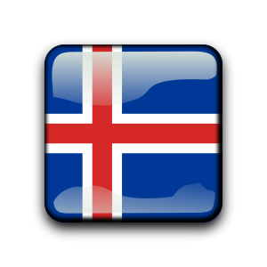
Building a Foundation:
Icelandic Groundwork Clinic
with Terral Hill
June 22nd & 23rd 2024
Sand Meadow Farm – Mendon, NY

Terral Hill is most well-known both in the US and Iceland for his successful application of natural horsemanship techniques to the training of Icelandic horses. His sensitivity and feel for the horses, helping them learn to trust and respect has gained him high praise from many of Iceland’s most famous riders/trainers. Training full time at his farm co-owned with his partner Carrie Lyons Brandt, Taktur Icelandic horses, Terral guides horses and riders to be happy and successful partners.

In this clinic Terral will focus on groundwork fundamentals for all levels of horses and riders – both young/untrained and fully/trained/ridden horses. Emphasis will be on shaping a willing, responsive, and confident equine partner ready for any endeavor.

This is a great “back to basics” opportunity for all Icelandic horse enthusiasts.

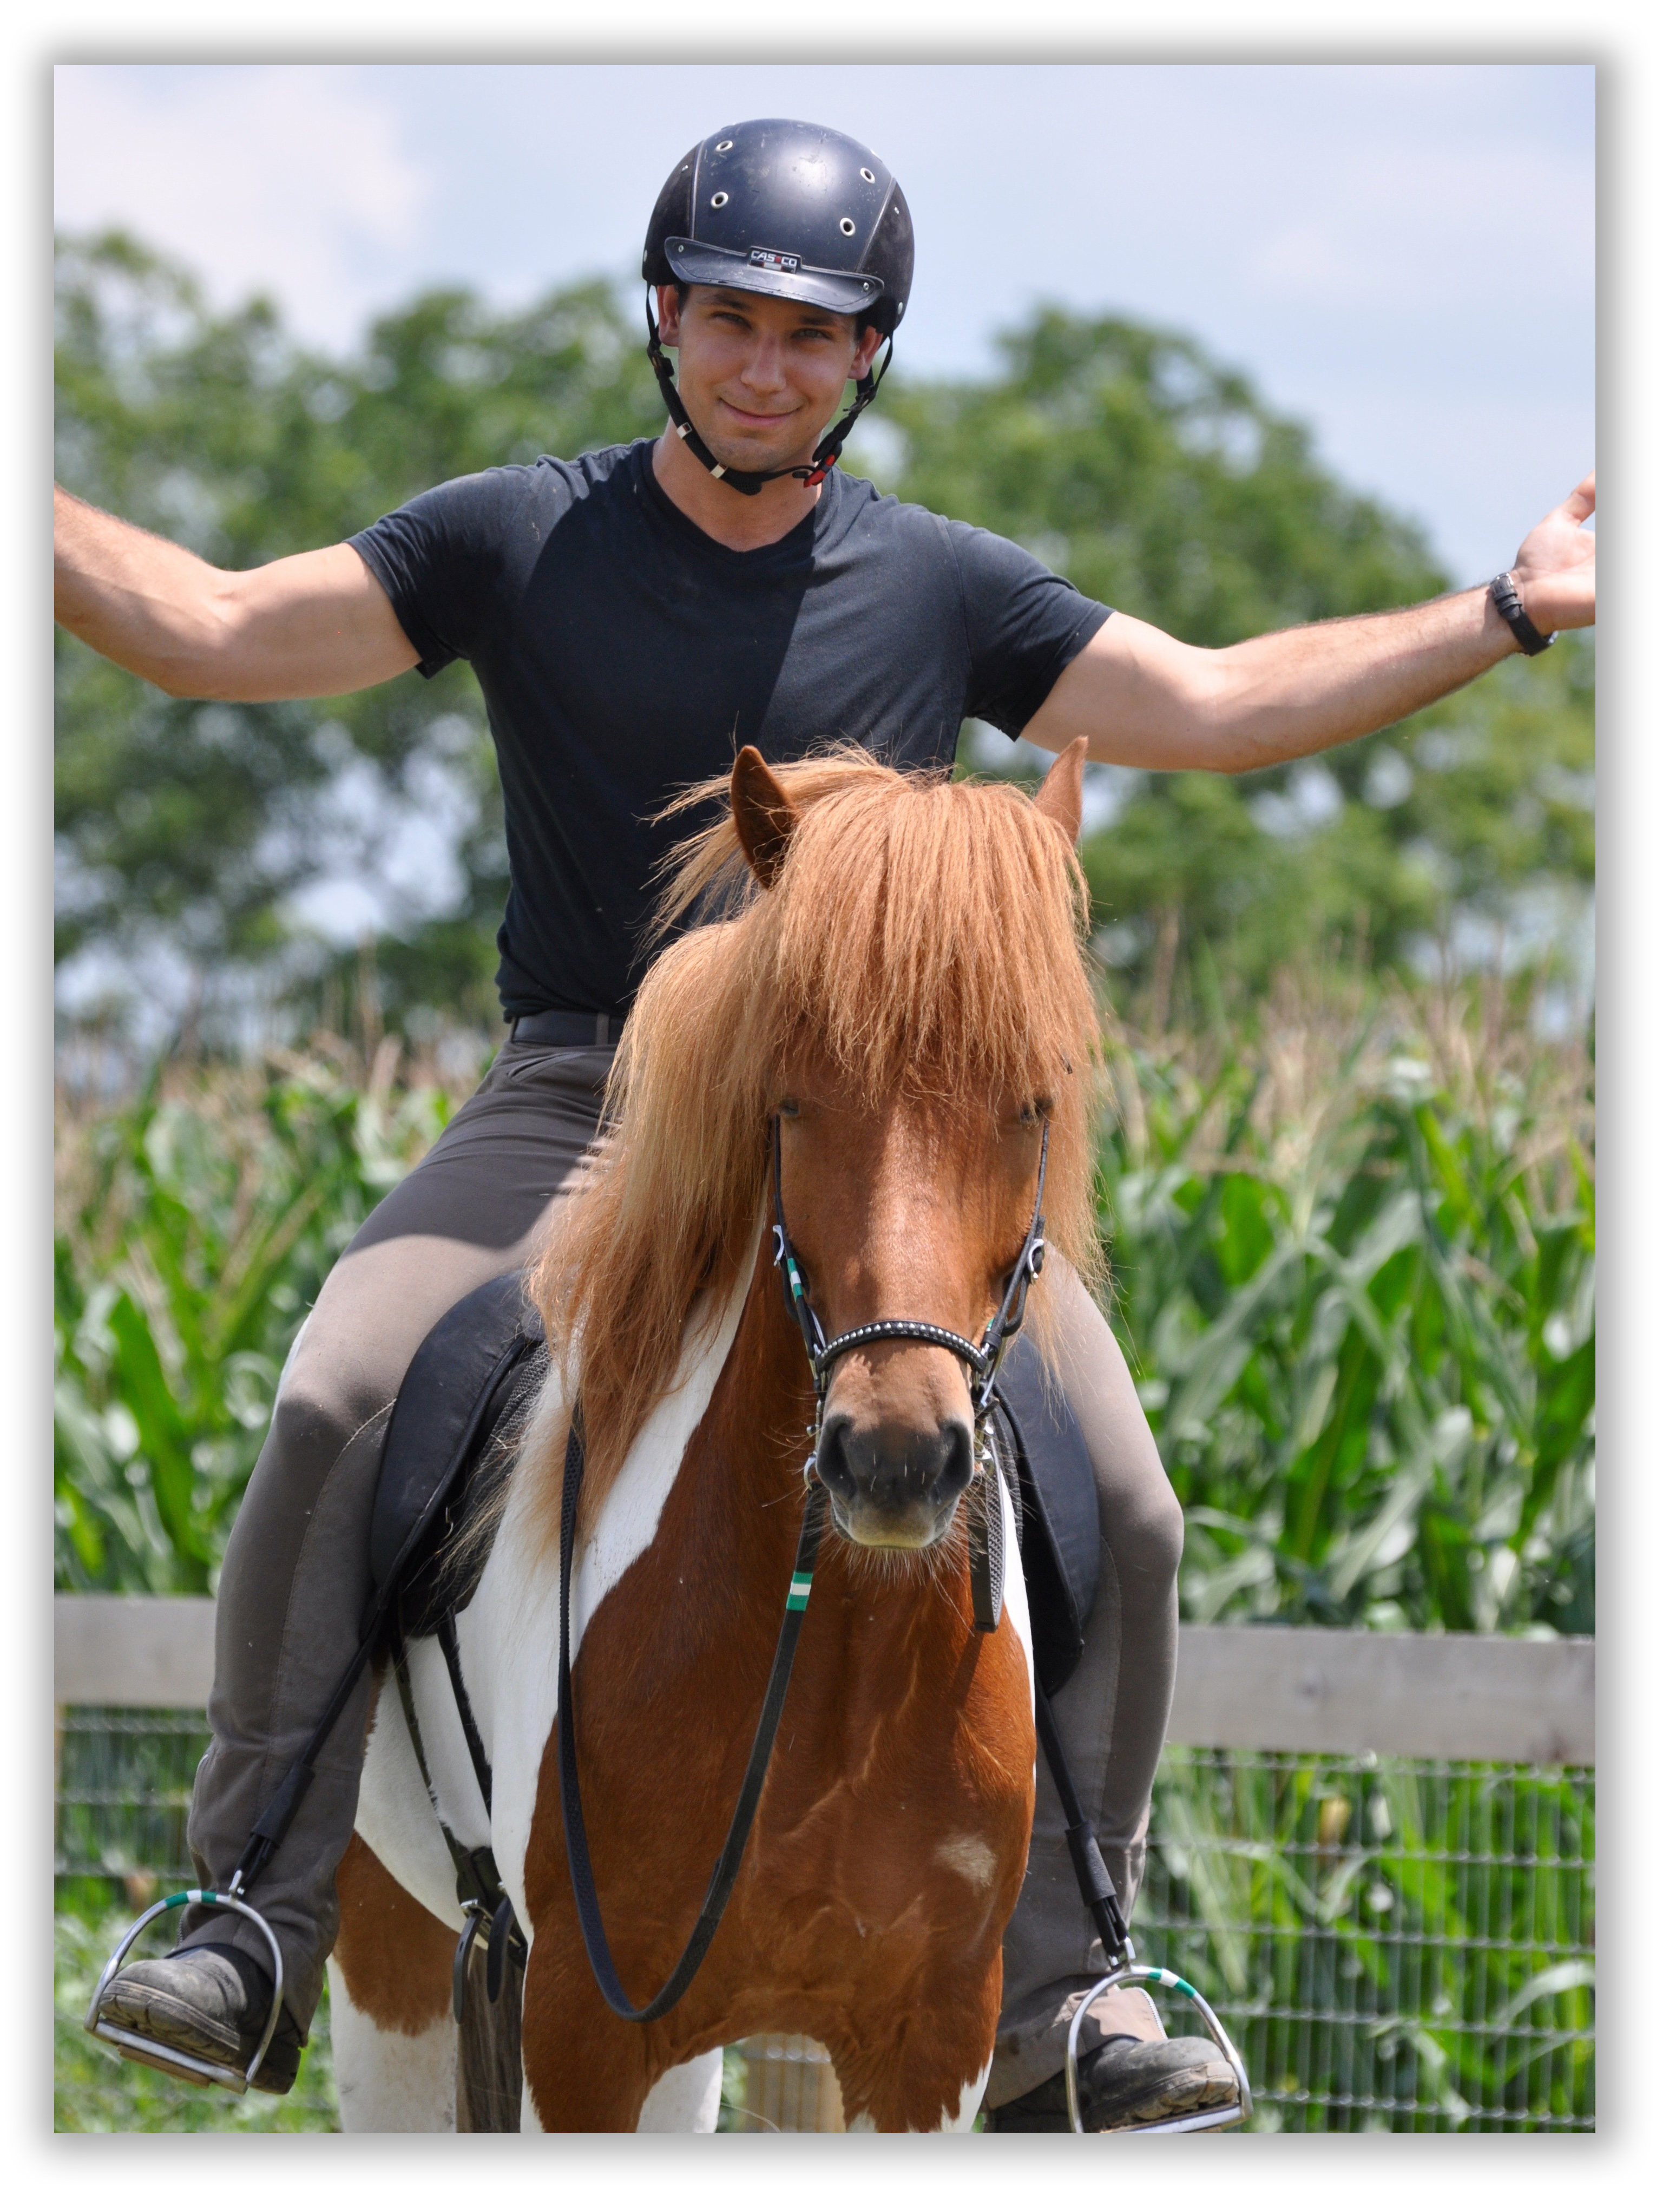

* Auditors are welcome with advance registration *
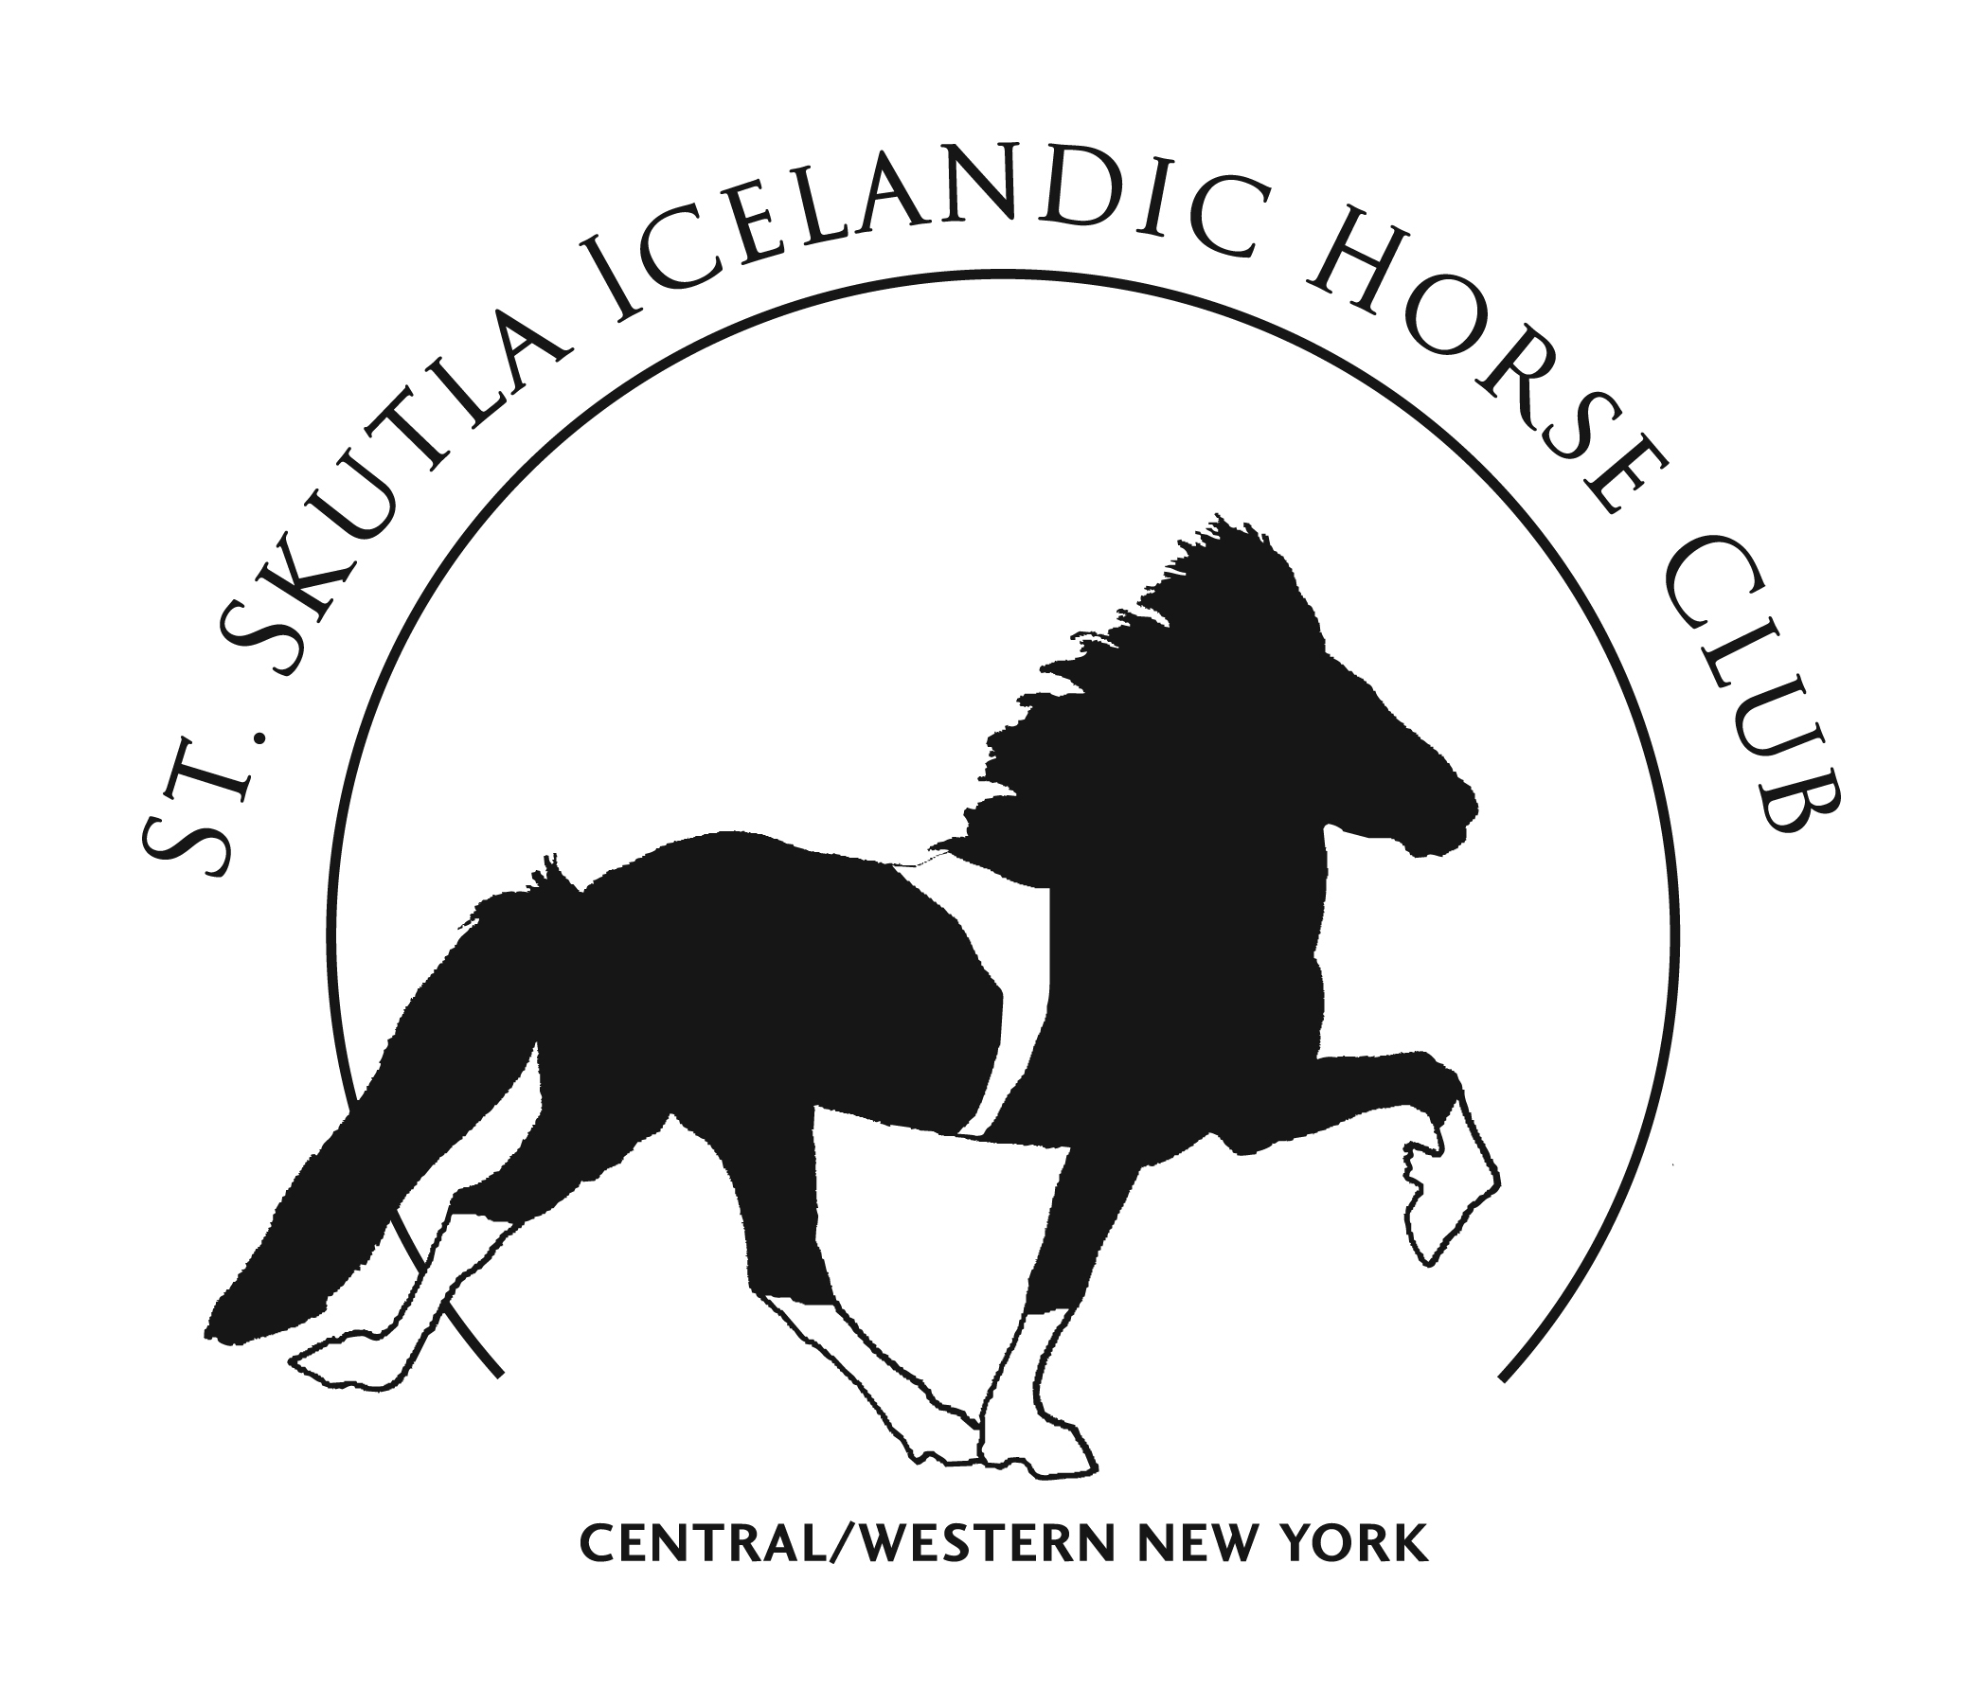
Contact:
Saint Skutla Icelandic Horse Club
Steven & Andrea Barber
toltstar@yahoo.com
585-624-4468

